Gay, transgender teens bond at Cape program

It’s a camp, a home, a sense of belonging

By Bella English
| GLOBE STAFF
AUGUST 05, 2013
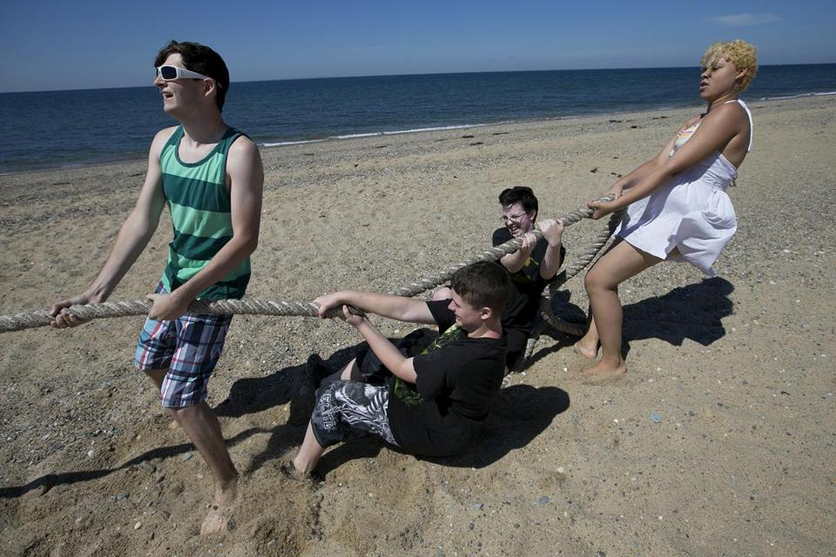
YOON S. BYUN/GLOBE STAFF
From left, Andrew Lawless, Morgan Yeager, Dan English, and Ghia Parow put their backs to a tug of war at Herring Cove Beach in Provincetown.

PROVINCETOWN — Two men are walking hand in hand down the main drag of this gay-friendly resort town at the tip of Cape Cod. No one pays any attention; being gay in P-Town is unexceptional.
But Andrew Lawless, who is 16 and from small-town Portland, Tenn., is impressed. “Wow, you don’t see that back home,” he says. The next day, he and fellow campers at Camp Lightbulb will see another first: They’re invited to the wedding of two men.
Camp Lightbulb is the only camp for lesbian, gay, bisexual, and transgender (LGBT) teenagers in the United States that is set in a gay-oriented community, and the only such summer camp in Massachusetts, says founder and director Puck Markham.
The son of an Air Force officer, Markham spent most of his childhood in the Netherlands and first came to Provincetown four years ago to visit friends. That is when the lightbulb went on.
“I’d read about the high rates of depression and suicide among gay youth, and I thought, ‘I should do something, and how cool would it be to have a camp in Provincetown?’ ” says Markham, who is 43 and gay, and who divides his time between London and Provincetown. He set up a nonprofit, raised money, and last year launched Camp Lightbulb for a one-week session in early August. Markham underwrote much of the cost himself.
This summer, thanks to word-of-mouth, more fund-raisers, and donations, the camp has expanded to four week-long sessions through Aug. 24. Though last year campers were drawn just from New England, this year kids come from several states, including Florida and California.
“For me, camp is about creating a positive steppingstone on their journey to becoming who they’re supposed to be,” says Markham, who runs a business providing financial education to low-income families. Last year, when he asked campers at the end of the week for one word to describe what Lightbulb had meant to them, the three most frequent responses were “community,” “love,” and “home.”
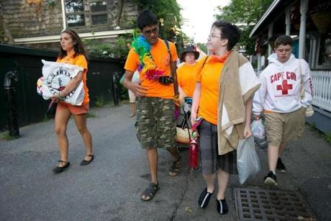
YOON S. BYUN/GLOBE STAFF
Dan English (second from right) spoke with Jake Davidson as they wheeled a cart carrying Camp Lightbulb supplies last Monday; at far left is Natalie Svanda and at far right is Morgan Yeager.
During the first week, which ended Saturday, half of the campers were gay or lesbian, half were transgender. The counselors and junior counselors were a similarly mixed group, and ranged from teenagers to senior citizens. The camp cost $650 a week, but 60 percent of the campers were on full or partial scholarship.
Chelsea Carey, 18, of North Bennington, Vt., was a camper last year and returned as a junior counselor this year because the experience had such a “positive effect on my life,” she says. “I feel more confident, and I wanted to help other kids get that same experience.”

Lightbulb has no traditional camp site per se. The kids and counselors sleep in tents at Dunes’ Edge Campground. Breakfast is cereal and fruit at the campground. Lunch is sandwich stuff wherever the group may happen to be. A church has offered its kitchen for dinner. Some meals are donated. And there is takeout.
The real campgrounds are the beaches and streets of P-town. Each of the four weeks will host a maximum of 10 kids ages 14 to 18, and there are almost as many counselors, many of them volunteers.
The first full day of camp, some of the teens sit on the beach talking about coming out to their parents, and which pronouns to use when one is transgender. They say they learned about Camp Lightbulb online, or from their school or their parents. Already, they are laughing and talking and seem comfortable with one another.
Morgan Yeager told his high school guidance counselor in Portland, Tenn., that he wanted to go to summer camp. “She looked it up and found this one,” says Yeager, who is 15. He says that being gay in a small Southern town is “really bad.”
His friend Andrew Lawless was assaulted in the school bathroom last winter. “I don’t use restrooms in public places anymore,” he says. He is thrilled to be at a camp where he can be himself. “I love it. Everything is an adventure that I want to experience, and the people are great.”

Although a few of the campers say they have openly disapproving parents, most have supportive families.
Elaine Mosgofian of Natick heard about Camp Lightbulb from a therapist last summer and thought her son Joey might be a good fit.
“He had some serious issues with bullying in school,” she says. “He had been depressed and miserable, but from the minute he arrived at camp, he was the old Joey that I knew.
They were making nametags and he just sat down and was off and running with these kids.”
Joey, now 17, stayed in touch with camp friends on Facebook and was adamant about returning this year. He will be there the last two sessions.
“It was tremendous what camp did for him,” says his mother. “He is happier and more confident, and last week, he did a fund-raiser for the camp. There’s nothing like this anywhere else.”
On the first day of camp this year, the main task is building a boat for Provincetown’s third annual Homemade Boat Race later that day. The rules are simple: Build a boat that will hold a person without sinking, and at push-off time, the skipper must paddle — with hands, a shovel, anything but real oars — out 20 yards and back.
By 11 a.m., Camp Lightbulbers are off with counselors to buy essentials for the race, which is sponsored by the Provincetown Center for Coastal Studies. Teams are to be judged on “ingenuity, aesthetics, and costumes.”
The campers on the costume committee have a $50 budget. Markham has already ordered orange T-shirts, so the kids scavenge through stores and come up with orange bandannas and beads along with some rainbow flags, suspenders, and boas, which are a big hit.
Daniel English, 15, is on the costume committee and happy to be away from Holbrook for a week. “Here I can be who I am,” he says. “It’s Provincetown.”
Indeed, the community has embraced the camp. As the kids walk down the street in their camp T-shirts, some applaud them. Several local businesses have donated space, funds, and prizes for the camp. An art gallery has lent a large room to serve as a clubhouse for arts activities, talks, and rainy days. The manager of a local health club is leading sports-related activities, including paddleboarding, kayaking, and obstacle courses.
Rob Anderson, 30, who opened The Canteen restaurant on Commercial Street last winter, says of the camp: “It’s an incredibly liberating experience to have this as a 15-year-old instead of a 25-, 35-, or even 55-year-old.”
While the costume committee shops, the boat committee has come up with what looks like an extra-large recycling bin as the hull, which will be buoyed by empty 5-gallon Poland Spring bottles lashed to the bin with duct tape. A couple of guys stuff foam peanuts into orange netting for further ballast.
Finally, the work is done, but the question remains: Will it float with a skipper aboard?
That would be Ghia Parow, a 16-year-old transgender girl who gingerly climbs into the bin, and begins paddling with a plastic shovel.
“I’m floating!” she shouts, to cheers.

